**Assignment 3: Practice SQL commands**

**SQL_D**

**Commands Executed:**

* CREATE
* SELECT
* UPDATE
* INSERT
* DELETE
* **SELECT * FROM ANIMALS;**

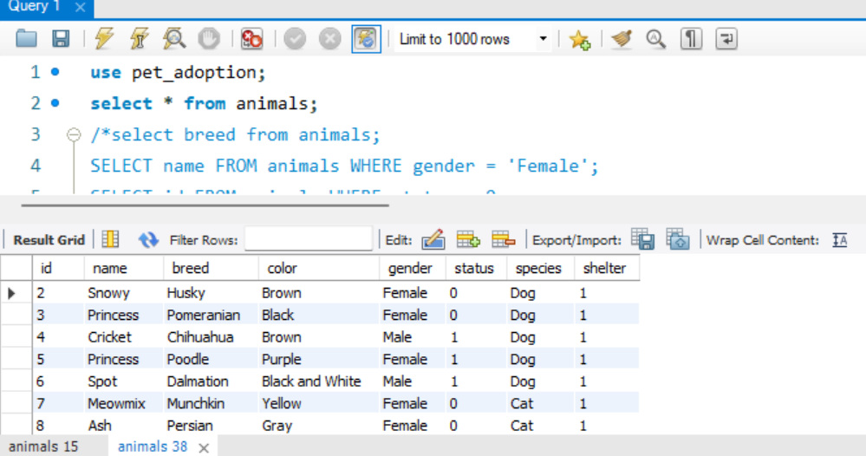

* **SELECT BREED FROM ANIMALS;**

* **SELECT NAME FROM ANIMALS WHERE GENDER = 'FEMALE';**

* **SELECT ID FROM ANIMALS WHERE STATUS = 0;**

* **UPDATE ANIMALS SET COLOR = 'BROWN' WHERE ID = '2';**
* **SELECT COLOR FROM ANIMALS WHERE ID=2;**
* **UPDATE ANIMALS SET COLOR = 'BROWN' WHERE COLOR = 'PURPLE';**
* **DELETE FROM ANIMALS WHERE ID = '1';**
* **UPDATE ANIMALS SET STATUS = 1 WHERE ID = '4';**

* **UPDATE ANIMALS SET STATUS = 1 WHERE ID = '4';**
* **INSERT INTO ADOPTIONS (ANIMAL_ID, NAME, CONTACT, DATE) VALUES ('10', 'PINOCCHIO', 'REALBOY@COCKROACHLABS.COM', NOW());**
* **UPDATE ANIMALS SET STATUS = 1 WHERE ID = '5';**
* **INSERT INTO ADOPTIONS (ANIMAL_ID, NAME, CONTACT, DATE) VALUES ('11', 'PATALIE', 'POODLEQUEEN@COCKROACHLABS.COM', NOW());**
* **UPDATE ANIMALS SET STATUS = 1 WHERE ID = '6';**
* **INSERT INTO ADOPTIONS (ANIMAL_ID, NAME, CONTACT, DATE) VALUES ('12', 'ELLA', 'ELLACREW@COCKROACHLABS.COM', NOW());**

* **SELECT * FROM ADOPTIONS ORDER BY DATE DESC;**

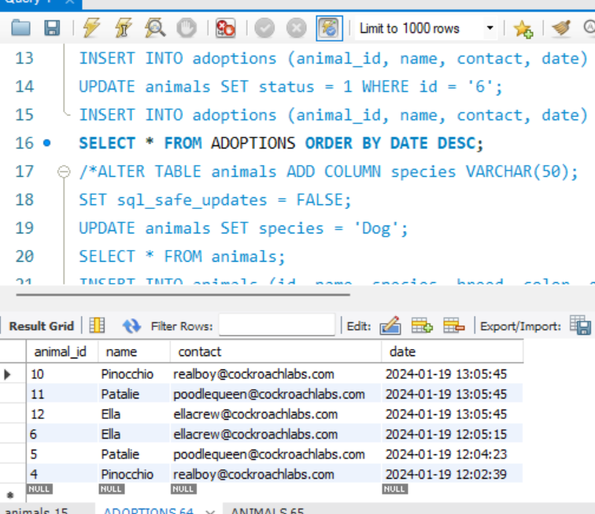

* **SET SQL_SAFE_UPDATES = FALSE;**
* **UPDATE ANIMALS SET SPECIES = 'DOG';**

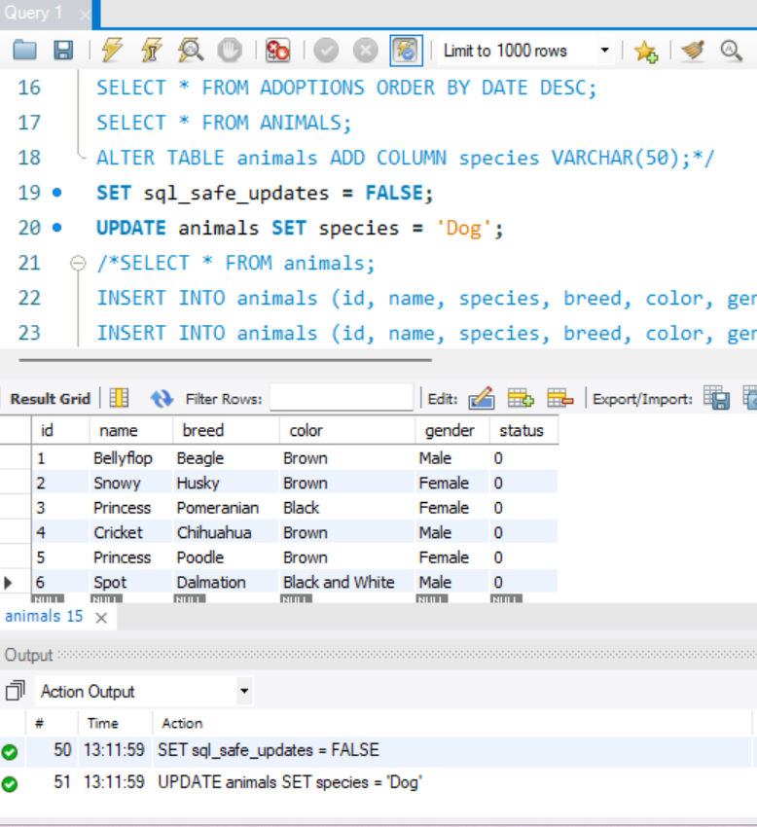

* **INSERT INTO ANIMALS (ID, NAME, SPECIES, BREED, COLOR, GENDER, STATUS) VALUES ('14', 'MEOWMIX', 'CAT', 'MUNCHKIN', 'YELLOW', 'FEMALE', 0);**
* **INSERT INTO ANIMALS (ID, NAME, SPECIES, BREED, COLOR, GENDER, STATUS) VALUES ('15', 'ASH', 'CAT', 'PERSIAN', 'GRAY', 'FEMALE', 0);**
* **INSERT INTO ANIMALS (ID, NAME, SPECIES, BREED, COLOR, GENDER, STATUS) VALUES ('16', 'TIGER', 'CAT', 'BENGAL', 'BROWN', 'MALE', 0);**

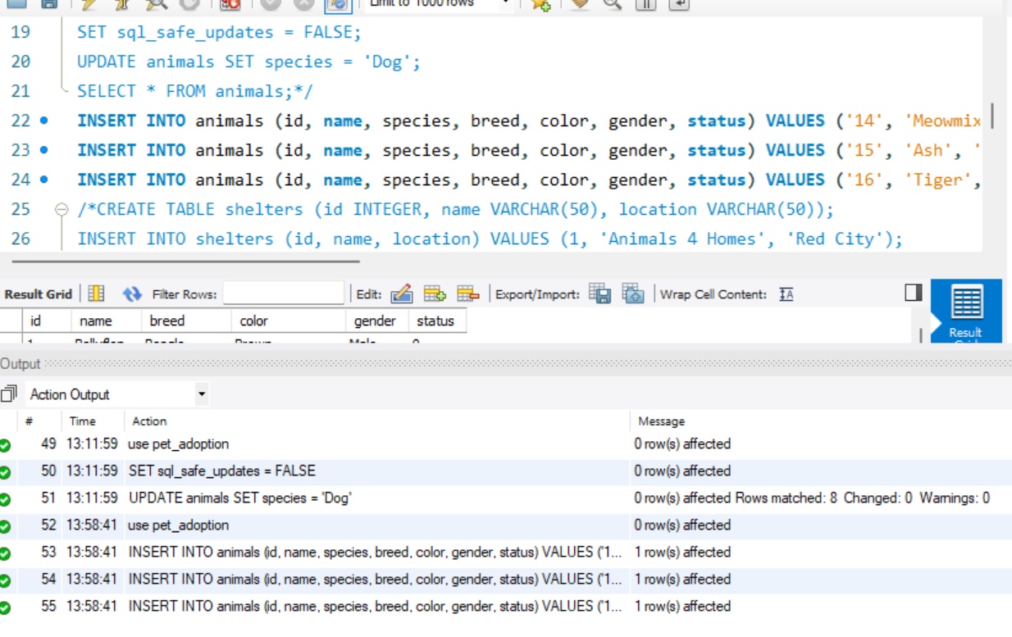

* **INSERT INTO SHELTERS (ID, NAME, LOCATION) VALUES (12, 'ADOPT A BUDDY', 'GREEN TOWN');**
* **INSERT INTO SHELTERS (ID, NAME, LOCATION) VALUES (11, 'FLUFFY ANIMALS', 'BLUE HILLS');**

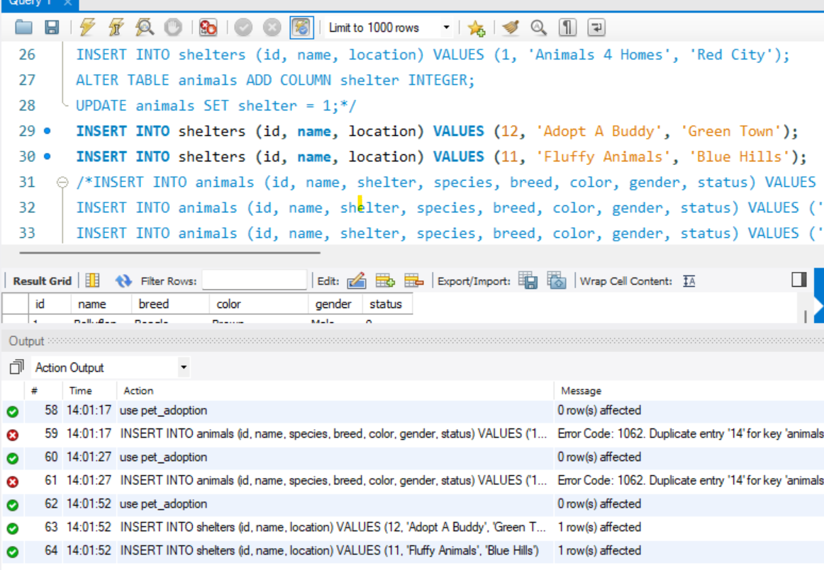

* **CREATE INDEX ANIMAL_SHELTER ON ANIMALS (SHELTER);**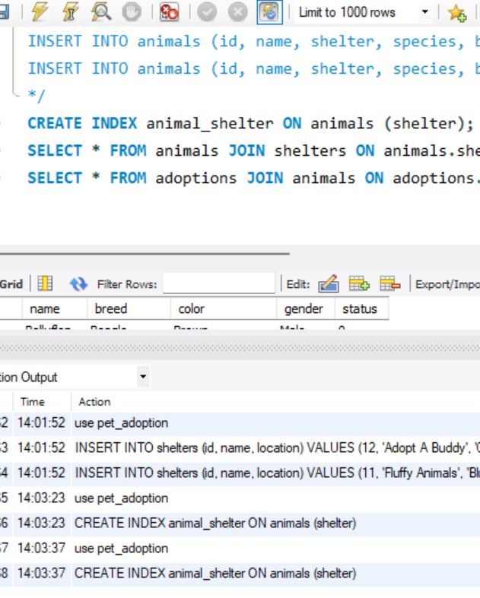
* **SELECT * FROM ANIMALS JOIN SHELTERS ON ANIMALS.SHELTER = SHELTERS.ID;**

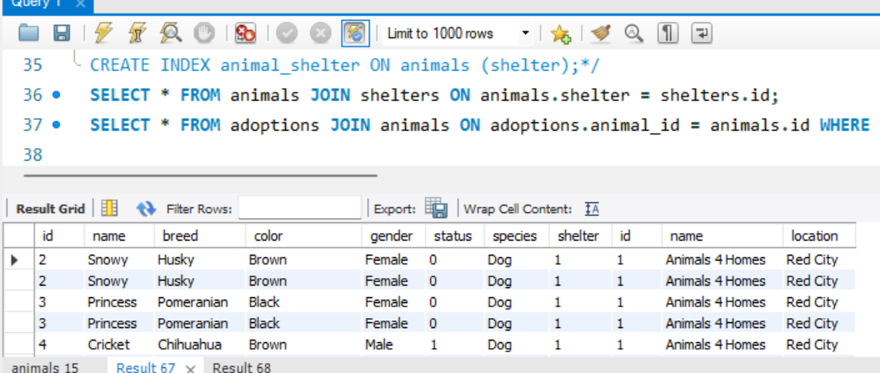

* **SELECT * FROM ADOPTIONS JOIN ANIMALS ON ADOPTIONS.ANIMAL_ID = ANIMALS.ID WHERE ANIMALS.SHELTER = 1;**

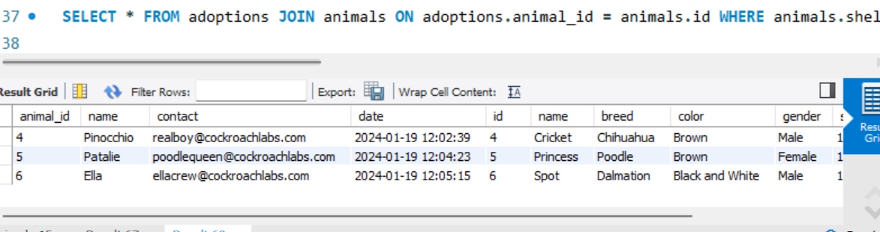

**SQL DAY**

**Commands Executed:**

* **Distinct**
* **Union**
* **Union All**
* **Commit**
* **Rollback**
* **Not In**
* **select distinct Username from admin;**

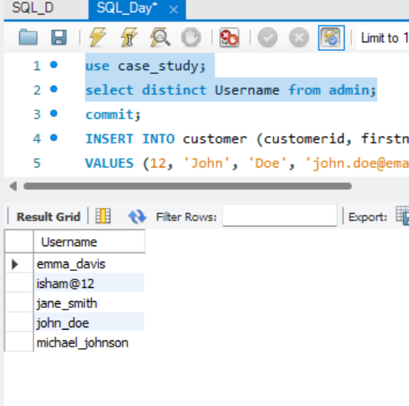

**select customerid from customer**

**union**

**select status from reservation;**

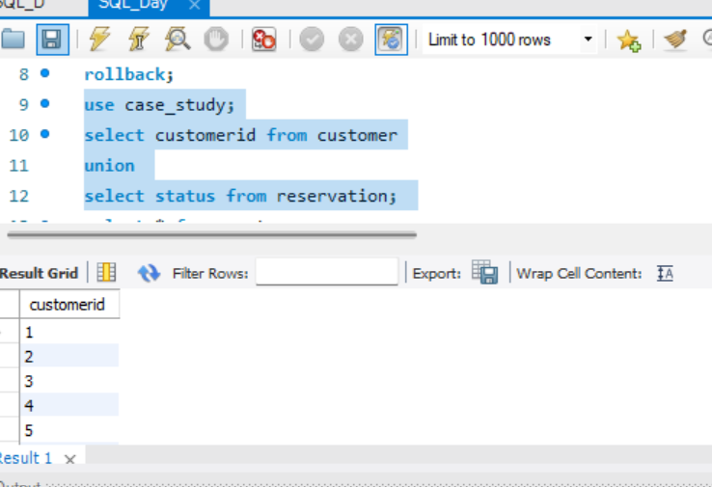

**select * from customer**

**union all**

**select * from admin;**

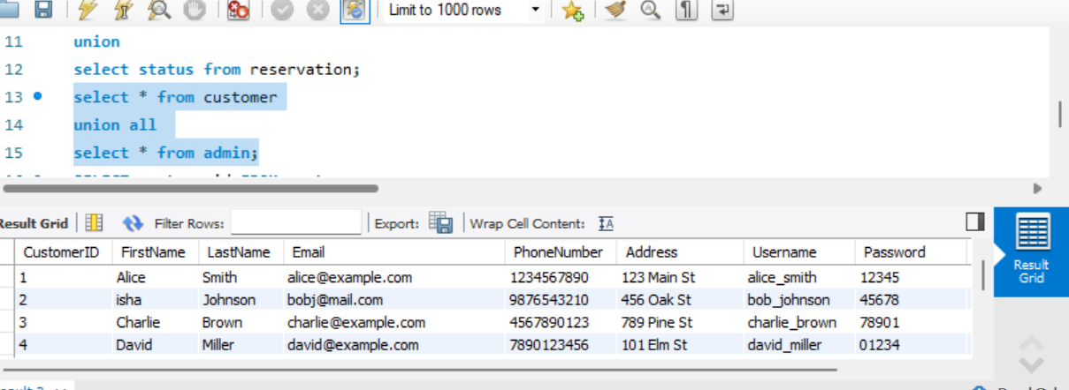

**commit;**

**INSERT INTO customer (customerid, firstname, lastname, email, phonenumber, address, username, password, registrationdate)**

**VALUES (12, 'John', 'Doe', 'john.doe@email.com', '1234567890', '123 Main St', 'jhndoe', 'password123', '2024-01-19');**

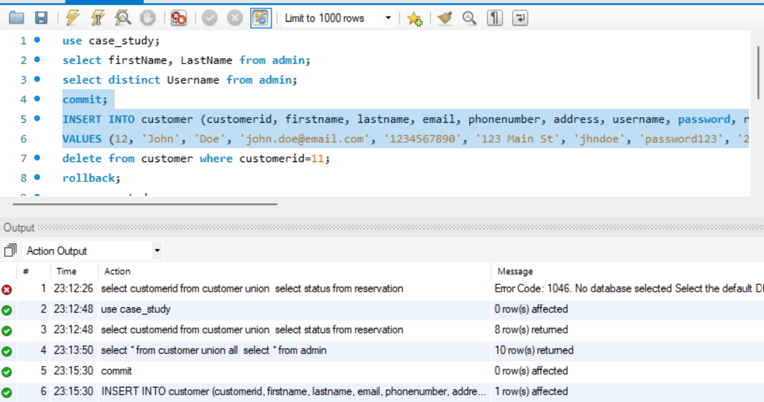

**commit;**

**delete from customer where customerid=11;**

**rollback;**

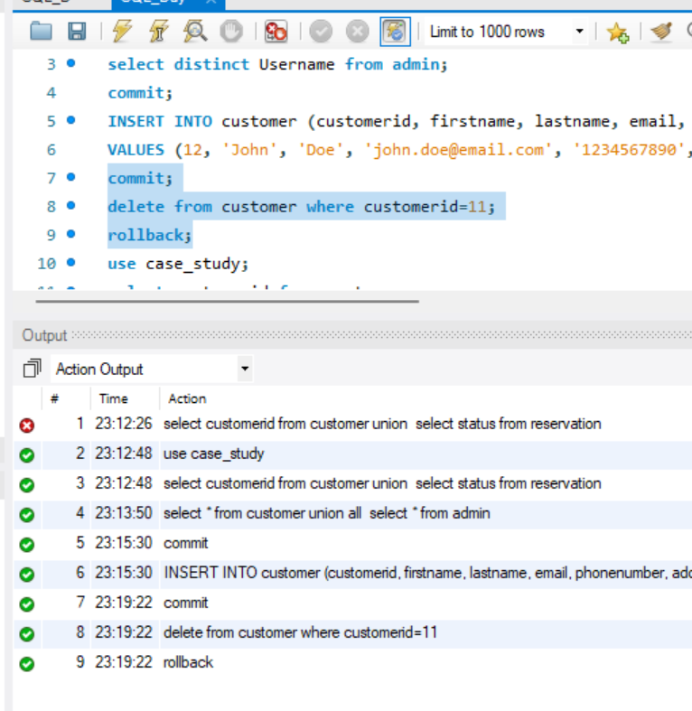

**SELECT customerid FROM customer**

**WHERE customerid NOT IN (SELECT adminid FROM admin);**

